***TASK#07(ETL)***

* **ETL (Extract, Transform, Load)**

**Process:** ETL is a data integration process where data is extracted from source systems, transformed into a suitable format, and then loaded into a target data warehouse or database.

1. **Extract:** The extraction step involves retrieving data from various sources.
   * ***Example****:* Imagine a healthcare provider extracting patient records, treatment data, and appointment logs from multiple medical systems.
2. **Transform:** During the transformation step, the extracted data is cleaned, formatted, and transformed to meet the requirements of the target system.
   * ***Example****:* The raw patient data might include inconsistent formats or missing values. The healthcare provider transforms this data to standardize formats, fill in missing information, and apply business rules such as combining treatment histories.
3. **Load:** The final step involves loading the transformed data into the target data warehouse or database.
   * 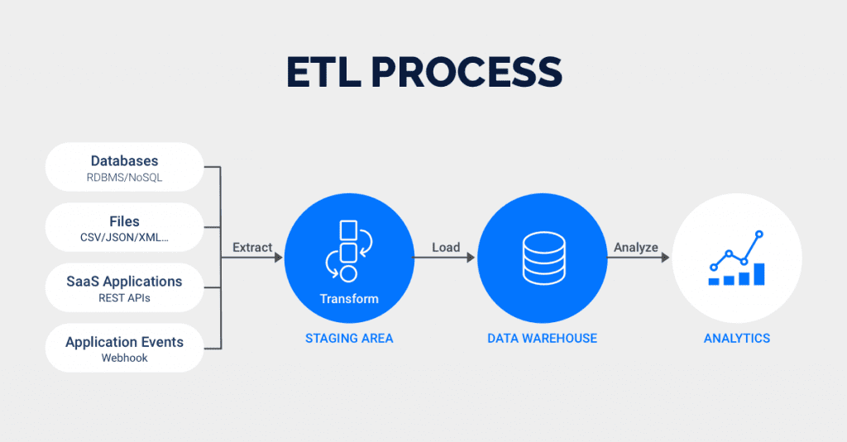***Example****:* The cleaned and standardized data is then loaded into a data warehouse, where analysts can access it to provide accurate patient insights.

**When to Use:**

* **Data Quality Priority:** When data accuracy and consistency are crucial before analysis.
  + ***Example****:* A healthcare provider needs accurate and consistent patient data to ensure quality patient care.
* **Complex Transformations:** When complex data transformations are needed before loading.
  + ***Example****:* A financial institution needs intricate calculations for risk scores before loading data into their system.
* **Legacy Systems:** When working with older systems that may not handle large-scale data processing efficiently.
  + ***Example****:* Traditional enterprises operating on older databases benefit from ETL as it aligns with their system capabilities.
* **ELT (Extract, Load, Transform)**

**Process:** ELT is a data integration process where data is extracted from source systems, loaded directly into the target system, and then transformed within that system.

1. **Extract:** The extraction step involves retrieving data from various sources.
   * ***Example****:* A social media company extracts massive amounts of user interaction data from its application servers.
2. **Load:** The loading step involves loading the raw data directly into the target data warehouse or database.
   * ***Example****:* This raw data is quickly loaded into a cloud-based data warehouse like Google BigQuery or Amazon Redshift.
3. **Transform:** The transformation step is performed within the target system, leveraging its processing power.
   * ***Example****:* The company then leverages the data warehouse's powerful processing capabilities to perform transformations, such as aggregating user engagement metrics and analyzing trends.

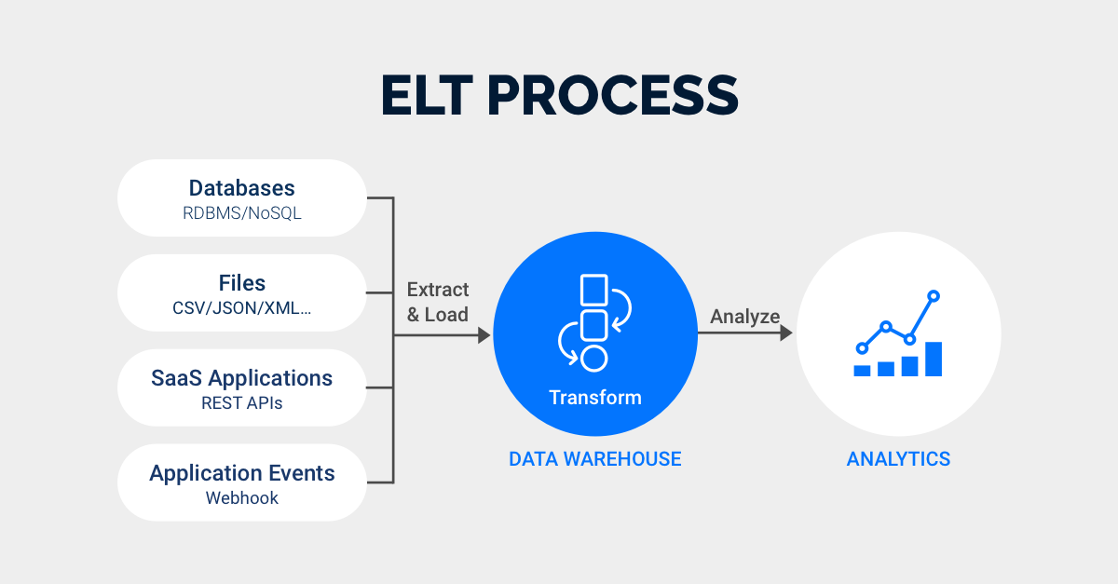

**When to Use:**

* **Large Data Volumes:** When dealing with large volumes of data that need to be loaded quickly.
  + ***Example****:* A video streaming service collects vast amounts of viewing data. To handle this efficiently, they load the data directly into a scalable data warehouse and perform transformations there, taking advantage of the cloud's processing power.
* **Modern Data Warehouses:** When using modern, scalable data warehousing solutions.
  + ***Example****:* Companies using modern data warehousing solutions like Snowflake can benefit from ELT. These systems are designed to handle large-scale data processing and provide efficient in-database transformations.
* **Real-Time Analytics:** When real-time data processing and analytics are required.
  + ***Example****:* An IoT company collects sensor data in real-time. By using ELT, they can load this continuous stream of data directly into their data warehouse and perform immediate transformations to monitor and respond to sensor readings in near real-time.

**Main Differences**

* **Order of Operations:** ELT loads data first and transforms it later, whereas ETL transforms data before loading.
  + ***Example****:* ELT is suitable for a video streaming service managing large data volumes, while ETL is used by a financial institution needing validated data before loading.
* **Processing Location:** ELT performs transformations within the target system, while ETL performs transformations outside the target system.
  + ***Example****:* ELT fits modern data warehouses; ETL aligns with legacy systems that require preprocessing.
* **Performance:** ELT can be faster for large datasets due to in-database processing, while ETL ensures data is clean and accurate before loading.
  + ***Example****:* ELT works for video streaming services; ETL is crucial for financial institutions to ensure data quality.
* **Data Quality:** ELT might introduce data quality issues if transformations are not managed properly post-loading, while ETL ensures data quality before loading.
  + ***Example****:* ELT might impact an e-commerce platform's sales reporting if inconsistencies are not addressed; ETL is critical for ensuring accurate transaction records.

**Use Case for ETL vs. ELT**

* **Scenario for ETL:** A healthcare provider needs to integrate data from various medical systems into a centralized data warehouse. Due to the critical nature of patient data, it is essential that the data is cleaned and standardized before loading to ensure accuracy and consistency.
* **Scenario for ELT:** A video streaming service collects vast amounts of user interaction data. To handle this efficiently, they load the raw data directly into a scalable cloud-based data warehouse and perform transformations there, utilizing the cloud's processing power to analyze viewing patterns and trends.
* **Batch Pipeline**

**Definition:** Batch pipelines process data in bulk at specific intervals. They handle large volumes of data collected over time before being processed together.

**When to Use:**

* **Periodic Processing:** Use batch pipelines when you can wait for a set period before processing the data. For instance, if daily or weekly processing is sufficient for your needs.
  + ***Example****:* An e-commerce company processes daily sales data to update inventory levels and generate end-of-day reports.
* **Resource-Intensive Tasks:** When the data processing tasks are complex and require substantial computational resources that can be scheduled during off-peak hours.
  + ***Example****:* Historical sales analysis where large datasets are processed in batches.
* **Historical Analysis:** Ideal for scenarios where you need to analyze accumulated data over time.
  + ***Example****:* Weekly sales reports and trend analysis.

***Example:*** An e-commerce website processes sales transactions at the end of each day to update inventory levels and generate sales reports. This approach allows the company to handle large volumes of data efficiently.

* **Streaming Pipeline**

**Definition:** Streaming pipelines process data in real-time as it arrives. This approach is suited for scenarios where immediate data processing and analysis are required.

**When to Use:**

* **Real-Time Processing:** Use streaming pipelines when you need to process and analyze data continuously as it is generated.
  + ***Example****:* A news media company monitors live news feeds and social media for breaking news.
* **Low Latency Requirements:** When immediate insights or actions are necessary, such as detecting anomalies.
  + ***Example****:* Real-time alerts for trending news and updates.
* **Continuous Data Flow:** Suitable for applications where data is constantly flowing and needs to be handled without delay.
  + ***Example****:* Live updates for news websites and social media platforms.

***Example****:* A news media company uses a streaming pipeline to process live data from news feeds and social media posts. This setup allows them to deliver real-time updates and breaking news coverage, responding to events as they happen.

**Main Difference**

* **Batch Pipelines:** Process data in large, discrete chunks at set intervals, ideal for periodic reporting and historical analysis.
* **Streaming Pipelines:** Handle data continuously in real-time, suitable for immediate insights and dynamic content management.

**Use Case for Batch vs. Streaming Pipelines:**

* **Scenario for Batch Pipeline:** An e-commerce platform processes sales data at the end of each day to generate daily sales reports and update inventory levels. The data is collected throughout the day and processed in bulk during off-peak hours to manage system resources efficiently.
* **Scenario for Streaming Pipeline:** A news media company uses a streaming pipeline to analyze live data from various news sources and social media. This allows them to provide real-time updates and breaking news coverage, responding to events as they happen.

